Exploring Physics Stage 3 Set 8

1.(a) P = VI (b) P = 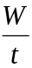 (c) V = IR
= 3000 x 20 W = 6.0x104 x 5 x 10-3 3.0 x 103 = 20R
= 6.0x10-4 W = 300 x J s-1 R = 150

2. P = 1373 Js-1 per m2
(a) Panel converts 137.3 Js-1 for each 1 m2
2000 Js-1 for each x m2
x = 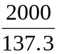
Area of panel = 14.6 m2

(b) P = V2/R
2000 = (50)2 /R
R = 1.25

3. (a) I = 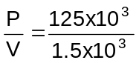 =
I = 83 A

(b) V = IR
R = 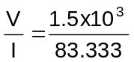

R = 18 A

4. Step down V_{p}I_{p} = V_{s}I_{s} to reduce V, I must increase so belongs to secondary coil as greater
current in secondary coil so need thicker wires (reduce resistance)

5. Assuming the coils are wound the same way, induced current in secondary coil set up so as to oppose existing current so induced magnetic field should oppose the magnetic field from the primary coil.

6. (a) V_{p}I_{p} = V_{s}I_{s}
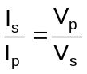 = 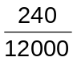 = 0.02 A
so say I_{p} is say 1.0 A, I_{s} will be 0.02 A

(b) 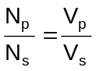
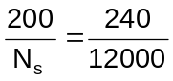
N_{s} = 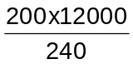 = 10 000 turns

- from part (a) for 100% efficient = 0.02 A
so 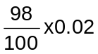
= 0.0196 times

7. (a) P = 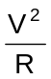
R = 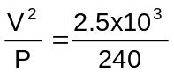
R = 10.04 Ω

(b) W = Vq
q = 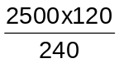
q = 1250 C

8 (a) P = VI
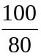x1000 = 12 I
I = 1.0 x 102 A

(b) The diameter is much greater to enable a large current to flow from the battery to the starter motor. The greater diameter also prevents electrical energy being wasted as heat energy.

9. (a) The role of a sub-station in an electrical grid system is to use transformers to step-down the voltage for distribution of electric power at lower voltages in the local area.

(b) The movement of electric trains consume much of the electric power provided by the sub-station. As the number of trains varies throughout the day so the amount of power available to nearby houses will fluctuate. One electric train will represent the same load as a large number of houses.

(c) Voltages over 1000V need to be transmitted along transmission lines held on much higher pylons to prevent arcing from occurring between the lines and the ground. This leakage of electrical energy through the air also causes television and radio interference and represents further power loss to the transmission system.

10(a) Power Loss = I2R Power Loss = I2R
P = VI = 250 x 250 x 0.5
500 x 103 = 2.0 x 103I = 3.13 x 104
I = 250 A = 31.3 kW

(b) P = VI Power Loss = I2R
500 x 103= 20 x 103I = 25 x 25 x 0.5
I = 25 A = 312.5 W
= 0.313 kW
= 0.313 kW

- To reduce power loss from the transmission lines. This is mainly in the form of heat.

12(a) Power Loss = I2R
P =VI Power Loss = VI
= 405 x 200 = 415 x 200
= 8.1 x 104 W = 8.3 x 104 W
Power Loss = 83 kW - 81 kW = 2 kW

(b) Power Loss = I2R Length = 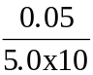-4
2 x 103 = 200 x 200 x R = 100 m
R = 0.05

(c) Place the motor separate to the left and near the transformer.

13 (a) Pin = x 5.0 kW
= 6.25 kW

(b) Power losses occur in the form of heat from the petrol engine, mechanical vibrations and sound from the moving components of the generator.

14. (a) Voltage is reduced
(b) Temperature is increased
(c) Brightness is reduced

15. P = VI P = VI
3.0 x 106 = 25 x 103 x I = 20 x 103 x 120
I = 120 A = 2.4 x 106 W

Power Loss = 3.0 x 106 - 2.4 x 10 6 = 0.6 x 106 W

Power Loss = I2R
0.6 x 106 = 120 x 120 R
R = 41.67

Distance = 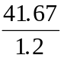
= 34.7 km

